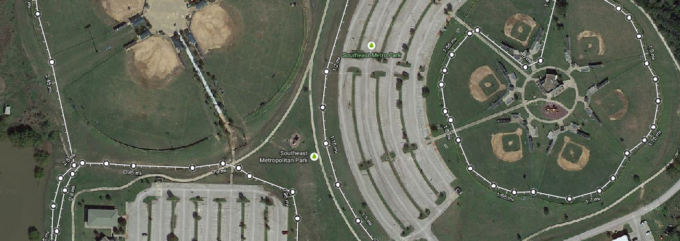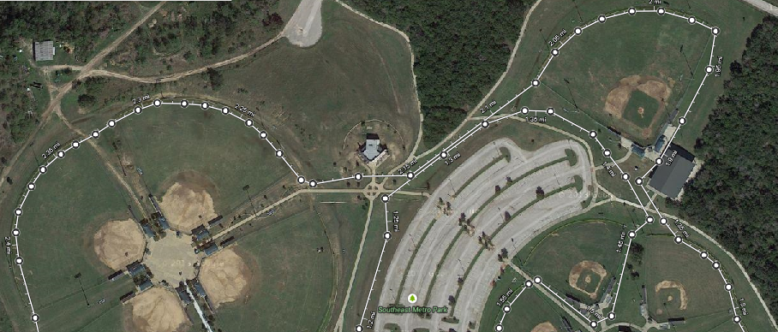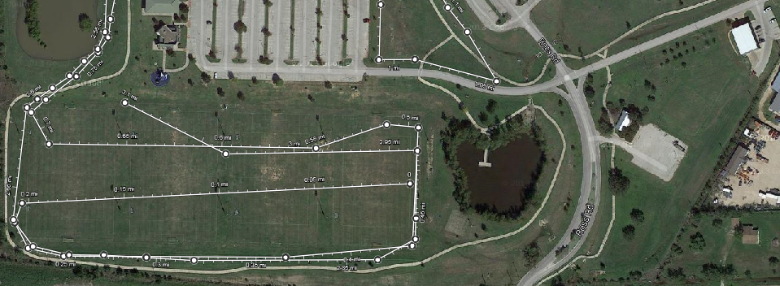**2015 CHAP INVITATIONAL - HS**

**Finish**

**START**



**Mile 2**

**Mile 1**

